Lesson 12 Class Activity

- Were you in class today (8 pts)?
- Were you on time to class today (4 pts)?

- Matched Paired t Procedure - A manager at an amusement park feels that the amount of time that people spend waiting in line for the roller coaster is too long. To determine if a new loading/unloading procedure is effective in changing wait time in line, he measures the amount of time (in minutes) people of waiting in line for seven days. After implementing the new procedure, he again measures the amount of time (in minutes) people are waiting in line on another 7 days (but same time frames) and obtains the following data:) (The link to the data is located in the “Lesson 12- Class Meeting” Section of Unit 2.– Use the ‘Wait Time A’ and ‘Wait Time B’ variables.)

- (1 pt) Why are the two types of wait-time samples dependent samples?
The wait times selected in the Wait-time B sample was dependent on the times selected in the Wait-time A sample.

- (1 pt) What are the degrees of freedom for this analysis?
df = 8
- (1 pt) Create and interpret a 95% confidence interval for the mean difference in the wait time between the two methods.
We are 95% confident that the mean difference in wait times is between -3.051 and 0.940.
- (1 pt) Does there appear to be a difference in the mean wait time between these two method?
Since zero is in the confidence interval, there is insufficient evidence to say that there is a true mean difference between the wait times.

- Matched Paired t Procedure – Now, the manager wants to think about it in terms of a hypothesis test. He wants to know if the mean wait time is different and used the level of significance of α = 0.05.

- (1 pt) Practice doing the numerical and graphical descriptive statistics for this analysis and include the results below.
Numerical – Mean and Standard Deviation of the differences
Graph – Histogram of the Differences
See below for all.
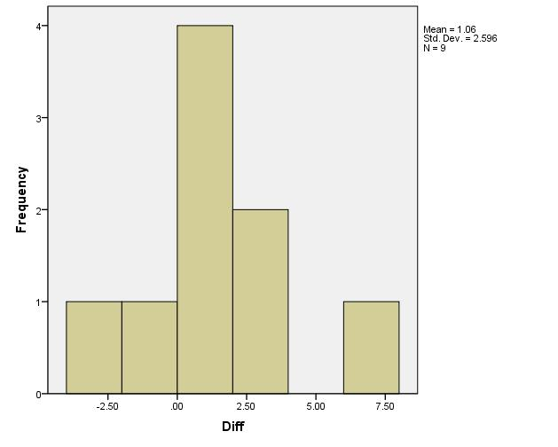
- (1 pt) Check the requirement (assumption) that the distribution of sample mean differences is bell-shaped.
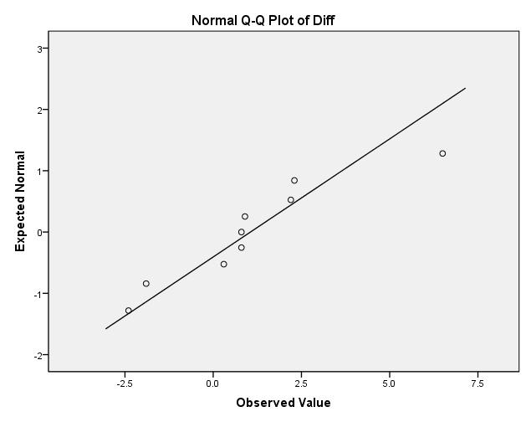
According to the QQ plot, the differences are approx. bell-shaped, so therefore, we can assume that the sampling distribution of all possible mean of differences is bell-shaped.
- (1 pt) State the null and alternative hypotheses
H_{o}: µ_{d} = 0 and H_{a}: µ_{d} ≠ 0
- (1 pt) Compute the Test Statistic for this analysis
t= -1.220

- (1 pt) What are the degrees of freedom in this analysis?
df = 8
- (1 pt) Determine P-Value based on Test Statistic. Sketch what the p-value looks like on a distribution curve.
p-value = 0.257

- (1 pt) What decision do you make based on the P-value and the level of significance (α).
Since the p-value is greater than the level of significance, we do not reject the null hypothesis.
- (1 pt) State your conclusion.
We have insufficient evidence to say that there is a mean difference between wait times before and after the change.

- (1 pt) With the wait time results, review your results with the confidence interval and the hypothesis test. Are there any connections? Why?
Doing a confidence interval and doing a two-sided test is basically the same thing and gives you the same results.

